An AI system can be developed with these three

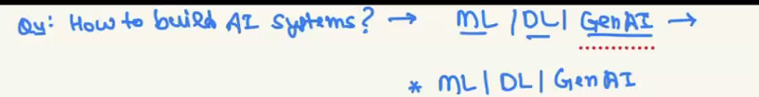

Overfitting and underfitting are analyzed in model evaluation phase

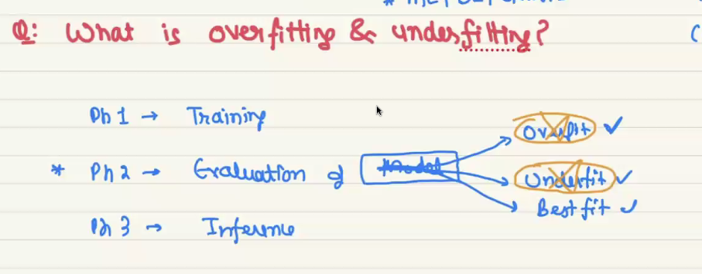

Underfitting is a problem in building ml model, it Is occurred when model doesn’t have enough good data to learn and predict.

When a model gives very low accuracy in evaluation phase then the model will be called as underfitted model.

We can also say that a model doesn’t learn well to make prediction, if a model is not make good prediction then directly we can say that model doesn’t have enough data to learn and that is called underfitting.

Overfitting also occurs when the model doesn’t learn the needed data instead of learning common patterns in all training samples it learns other things which is not needed to make prediction.

In training phase the model is return 90 in evaluation model is return very low accuracy then it is called overfitting.

Below image will gives you the example of when will the model is called over and under fitting

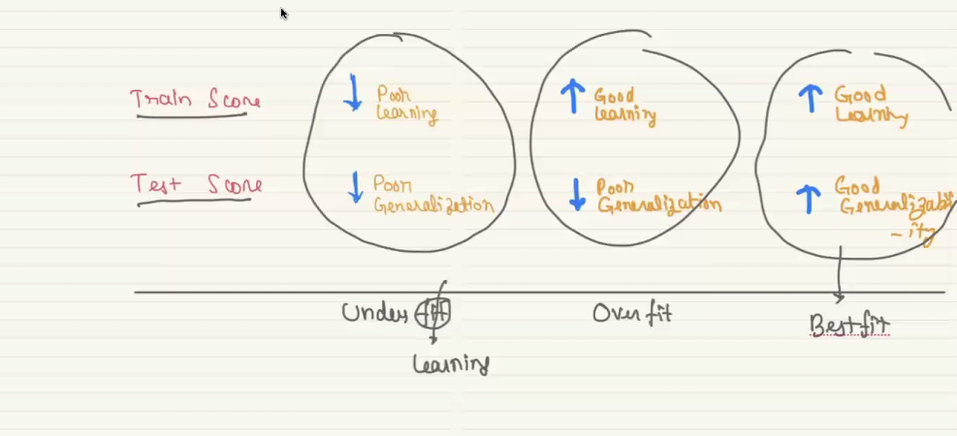

3. overfit

1. underfit

2. best fit

In the below image

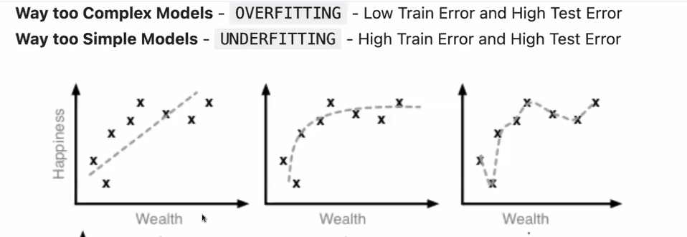

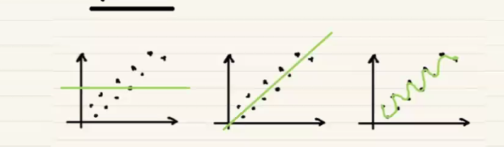

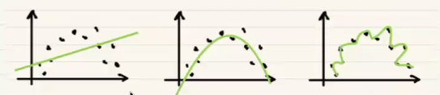

Below image is the example of over and under fit in categorical data (classidficatio), while above if for regression problem

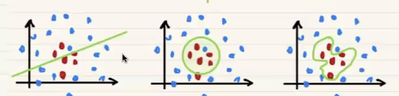

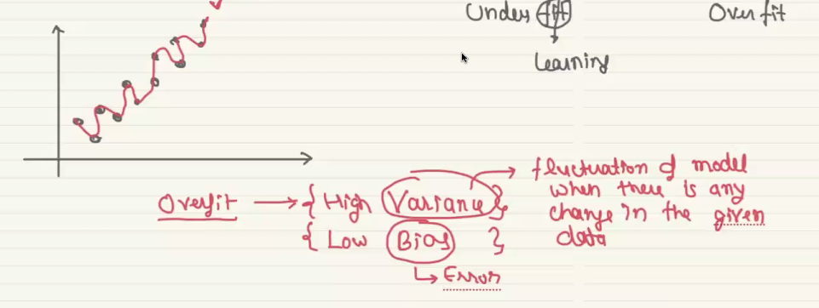

Variance describes how model changes it’s performance when given data is changed, example in below image

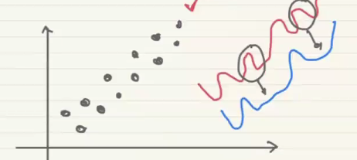

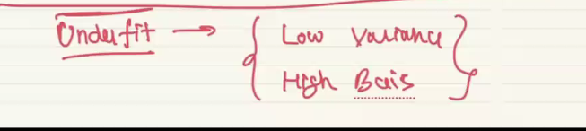

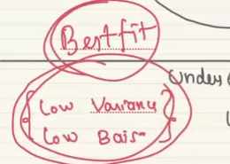

Accuracy score is the value helps to find if the model is overfitted and underfited, or best fitted. To calculate accuracy of train and test data there are several calculations are available for classification and regression model.

Example calculation method for both are the following

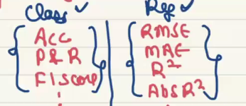

**HYPER PARAMTER TUNING:**

This is the method which helps to increment the accuracy score of the model, it is one of the method.

But it takes a lot of time, **k-fold cross validation** is also one of the method for hyper parameter tuning

Hyper parameter does the model tuning, it is like radio tuning to correct channel to avoid noise on other channel’s frequency.

KNN and decision tree have the hyper parameter tuning by default.

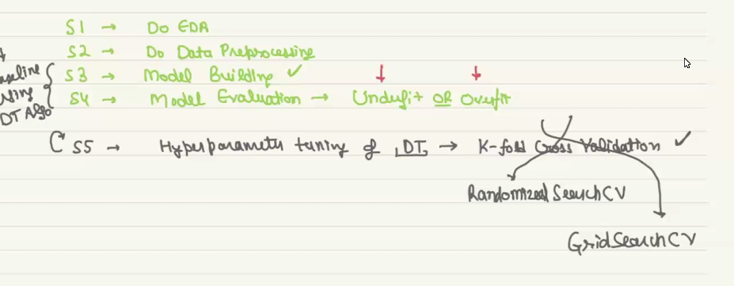

**GEN AI**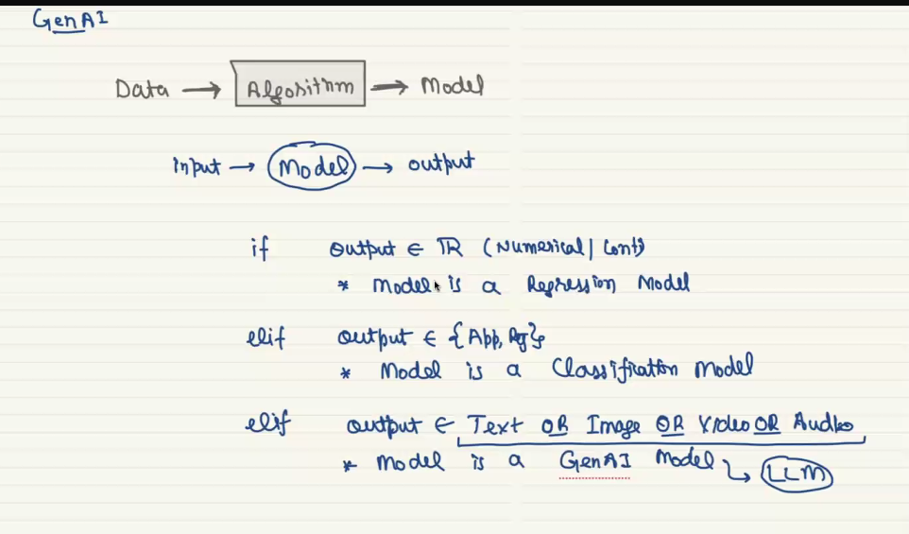

Transforms is the algorithm that helps to build gen ai

